INTRODUCTION TO UML

UML DEFINITION:-

The Unified Modeling Language (UML) is a standard language for writing software blueprints. The UML uses mostly graphical notations to express the design of software projects.

The UML is a language for
- Visualizing
- Specifying
- Constructing
- Documenting
the artifacts of a software intensive system.

Uml is a very expressive language, addressing all the views needed to develop and the deploying such system. It is not difficult to understand and to use .
Learning to apply UML starts with forming a conceptual model of the language which requires learning UML’s basic building blocks, the rules that dictate how these building blocks may be together and some common mechanisms that throughout the language.

Application of UML:-

The UML is intended primarily for software intensive system. It has been used effectively for such domains as

  - Enterprise information system.
  - Banking and financial services.
  - Telecommunication.
  - Defense/aerospace.
  - Retail
  - Medical electronics.
  - Scientific.
  - Distributed web based services.

The UML is not limited to modeling software. It is expressive enough to model non software system, such as workflow in the legal system, the structure and behaviors of a patient health care system, and the design of hardware.

Goals of UML:

The primary goals in the design of the UML were:
- Provide users with a ready-to-use, expressive visual modeling language so they can develop and exchange meaningful models.
- Provide extensibility and specialization mechanisms to extend the core concepts.
- Be independent of particular programming languages and development processes.
- Provide a formal basis for understanding the modeling language.
- Encourage the growth of the OO tools market.
- Support higher-level development concepts such as collaborations, frameworks, patterns and components.
- Integrate best practices.

Definition of Modeling:-

Modeling is overall design of the system.

- Modeling captures essential parts of the system.
- Modeling is a central part of all the activities that lead up to the deployment of good software.
- We build models to communication the desired structure and behavior of our system.
- We build models to visualize and controls the system’s architecture
- We build models to better understanding the system we are building, after exposing opportunities for simplification and reuse.
- We build models to manage risk.

Principles of Modeling:-

The use of modeling has a rich history in all the the engineering disciplines. That experience suggests four basic principles of Modeling.

- the choice of what models to create has a profound influence on how a problem is attacked and how a solution is shaped.
- Every model may be expressed at different levels of precision.
- The best models are connected to reality.
- No single is sufficient every nontrivial system is best approach through a small set of nearly independent models.

Building blocks of UML:

The vocabulary of the uml encompasses three kinds of building blocks.
1. Things
2. Relationships
3. Diagrams.

Things are the abstractions that are first class citizens in a model; relation ships these things together; diagrams group interesting collections of things.

Things in uml:

There are four kinds of things in uml. They are
1. structural things
2. behavioral things
3. grouping things
4. An notational things.

Structural things:

These are the nouns of uml models. These are mostly the static parts of model. In all these are seven kinds of structural things. They are

- class 5. Active class
- Interface 6. Component
- collaboration 7. Node
- usecase

1. Class:-

A class is description of a set of objects that share the same attributes, operations, relationship, and semantics.

A class implements one or more interface classes are the most important building blocks of any objects-oriented system. We can use classes to represent software thing, hard ware thing, and even things that are purely conceptual.

Graphically, a class is rendered as a rectangle, usually including

Name of the class

Every class must have distinguished it from other classes. A name is a textual string name is a simple name or a path name path name is the class name prefixed by name of the package in which that class lies.

Attributes:-

An attributes is a named property of a class that describes a range of value that instances of the property may hold, A class may have any number of attributes or no attributes at all An attributes represents some properly of the thing we are modeling that is shared by all objects of that class. Graphically, attributes are listed in a compartment just below the class name.
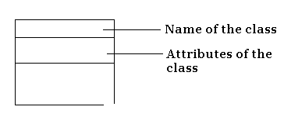

Operations:-

An operation is the implementation of a service that can be requested from any object of the class to affect behavior. In other words, an operation is an abstraction of something you can do to an object and that is shared by all objects of that class. A class may have any number of operation or no operation at all graphically operations are listed in a compartment just the class attributes.

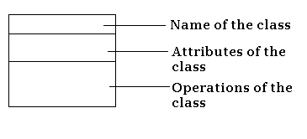

Responsibilities:-

A responsibility is a contract or an obligation of a class when create a class, we are making a statement that all objects of behavior. At a more abstract level, these corresponding attributes and operations are just the features by which the class’s responsibilities are carried out.

A class may have any number of responsibility. As we refine our models, we will translate these responsibilities into a set of attributes and operations that best fulfill the class’s responsibilities. Graphically, responsibilities can be drawn in a separate compartment at the bottom of the class icon.

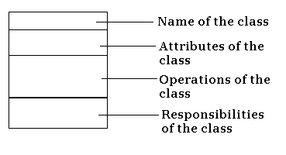

2. Interface :-

An interface is a collection of operation that specify a service of a class or component. An interface therefore describes the externally visible behavior of a class or component or only a part of that behavior. An interface is rendered as a circle together with its name.

Is spelling

3. Collaboration:-

to provide some co-operative It is an interaction and is a society of roles and other elements that work together behavior that’s bigger than the sun if all elements .graphically it is represented as ellipse with dashed lines usually including only its name .

4. Usecase:

It is a description of set of sequence of actors that a system performs yields on observable result of value to a particular actor graphically it represented as an ellipse with solid lines usually including only its names.

5. Active class:

It is a class whose objects own one or more processes or threads and therefore can initiate control actively .it is graphically represented as just like a class but with heavy lines, usually including its name, attributes and operations.

EVENT MANAGER

Suspend()
Fluh()

6. Component:-

A component is a physical and replaceable part of a system that conforms that conforms to and provides the realization of a set of interface. A component typically represents the physical package of otherwise logical elements such as class interfaces, and collaborations. Graphically, a component is rendered as a rectangle with tabs, usually including only its name.
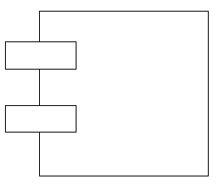

7. Node:-

A node is a physical element that exits at runtime and represents a computational resource, generally having at least some memory and, often, processing capability. A set of components may reside on a node and may also migrate from node to node. Graphically , node is rendered as a cube, usually including only its name.

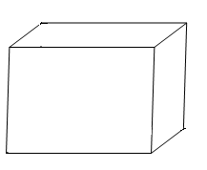

Behavioral things:

These are the dynamic parts of uml models. These are the verbs of a model, representing behavior over time and space, these are two types.
1.Interaction
2.state machine

1. Interaction:

. It is a behavior that compare a set of messages exchanged among a set of objects with in a particular context to accomplish a specific purpose graphically represented as a directed line, almost always including the name of its operation
Display

2. state machine:

It is a behavior that specifies the sequence of states an object or an interaction goes through during its lifetime in response to events, together with its responses to these events. A state machine involves a number of other elements, including states, transitions events and activities graphically it is represented as a rounded
Rectangle , including its name and its subsets.

Waiting

Grouping things:

These are organizational parts of uml models. These are the boxes into which a model can be decomposed. In all, there is one primary kinds of groping thing namely packages.

package:

It is a general purpose mechanism for organizing elements into groups structural, behavioral and even other grouping things may be placed in a package it is purely conceptual. Graphically represented as a tabbed folder including only its name and sometimes, its contents.

Business rules

An notational things:

Those are the explanatory parts of uml models. These are the comments you may apply to describe illuminate and remark about any element in a model. There is one primary kinds of Annotational thing called a note.

Note:

It is a simply symbol for rendering or a collection of constructs and comments attached to an element or a collection of elements, graphically it is represented as a rectangle with a dog eared corner together with a or a graphical comment.

Return copy of self

Relationships in UML :

A relationship is a connection among things. In object oriented modeling, there are three kinds of relationships that are especially important.

- Dependencies which represent using relationships among classes
- Generalization which link generalized classes to their specialization
- Associations which represent structural relations among object.
- Realization which represent relation among class and interface or
Usecase and collaboration

Each of these relationships provides a different way of combining the abstraction. Graphically, a relationship is rendered as a path, with different kinds of lines used to distinguish the kinds of relationships.

1. Dependency:-

A dependency is a using relationship that states that a change in specification of one thing may affect another thing that uses it, but not necessarily the reverse. Graphically, a dependency is rendered as a dashed directed line, directed to the thing being depended on. We use dependencies when we want to show out thing using another thing.

2. Generalization:-

A generalization is a relationship between a general thing and a more specific kind of that thing. It is something called an “is-a-kind-of” relationship. Generalization means that objects of the child may be used anywhere the parent may appear, but not the reverse i.e., the child is substitutable for the parent. A child inherits the properties of its parents, especially their attributes and operations. An operation of a child that has the same signature as an operation in a polymorphism. Graphically, generalization when we want to show parent/child relationships.

A class may have zero, one or more parents. A class that has next parents and one or more children is called a root class or a base class. A class that has no children is called a leaf class. A class that has exactly one parent is said to use multiple inheritance.

3. Association:-

An association is a structured relationship that specifies that object of one thing are connected to objected of another. Given an association connecting two class, we can navigate from an object of one class to an object of the other class, and vice versa. It’s quite legal to have both ends of an association circles back to the same class. This means that, given an object of the class, we can link to other object of the same class. An association that connect exactly two classes is called a binary association. Graphically an association is rendered as a solid line connecting the same or different classes. Use association when we want to shoe structural relationship.

Beyond this basic form, There are four adornments that apply to associations.

Name:-

An association can have a name, and we use that name to describe the nature of the relationship. So that is no ambiguity about its meaning, we can give a direction to the name by providing a direction triangle.

Role:-

When a class participates in an association it has a specific role that it plays in that relationship, It has a specific role that it plays in that relationship . Role is just the face the class at the near end of the association presents to the class at the other end of the association. We can explicitly name the role of a class plays in an association.

Multiplicity:-

An association represents a structural relationships among objects. In many modeling situation, it’s important for us to state how many objects may be connected across an instance of an association. This “how many”, is called the multiplicity of an associations role, and is written as an expression that evaluates to a range of values or an explicit value.
When we state a multiplicity at one end of an association, we are specifying that, for each object of the class at the opposite end, there must be that many object at the near end.

Aggregation:-

A plain association between two classes represents a structural relationship between peers, meaning that both classes are conceptually at the same level, no one more important than the other. Sometimes, we will want to model a “whole/part” relationships in which one class represents a larger thing, which consists of smaller things. This kind of relationship is called aggregation, which represents a “has-a” Relationship, meaning that an object of the whole has object of the part.

Composition:-

composition specifies a strong form of aggregation in which every part also get deleted when we want to delete whole thing. Graphically it is represented with solid diamond with a line.

4. Realization:

It is a semantic relationship between classifier where in one classifies a contract that another classifier guarantees to carry out this relationship encounters that realize them graphically it is represented as a cross between a generalization and a dependency relationship

Diagrams in uml:

Diagram is the graphical presentation of a set of elements most represented as a connected graph of vertices (things)&Arcs (relationships). Draw diagrams to visualize a system from different perspectives . The uml includes nine such diagrams they are:

Structural Diagrams are:
1. Class diagrams
2. Object diagrams
3. Usecase diagrams
4. Sequence diagrams
Behavioral Diagrams are
1. Collaboration diagrams.
2. State chart diagrams.
3. Activity diagrams
4. Component diagrams
5. Deployment diagrams.

Class diagram:

It shows set of classes’ interfaces and collaborations & their relationships. These address the static design view of a system these that include active classes address the static process view of a system. Class diagrams models class structure and contents using design elements such as classes, packages and objects. It also displays relationships such as containment, inheritance, associations and others.

Object diagram:

It shows a set objects and their relationships. These represents static snapshots of instances of the things found in class diagram.

Use case diagram:

It shows a set of use cases and actors and their relationships use case diagrams address the static (view)use case view of a system importance in organizing and Modeling the behavior of a system.

Sequence diagram:
Sequence diagram emphasizes the time ordering of messages. It mainly shows set of objects and the messages send /receive by those objects which is concerned with time ordering of messages. It displays the time sequence of the objects participating in the interaction. This consists of the vertical dimension (time) and horizontal dimension (different objects).

Collaboration diagram:

It is an interaction diagram. Focuses on set of objects and messages, which is related to the structural organization of objects that send and receive messages. It displays an interaction organized around the objects and their links to one another. Numbers are used to show the sequence of messages.

State chart diagram:

It shows a state machine, consisting of states, transitions, events and activities. This is dynamic view of system and emphasize the event ordered behavior of an object, which is especially useful in modeling reactive system. It displays the sequences of states that an object of an interaction goes through during its life in response to received stimuli, together with its responses and actions.

Activity diagram:

It is a special kind of state chart diagram that shows the flow from activity to activity within a system. it address the dynamic view of a system. Emphasize flow of control among objects. It displays a special state diagram where most of the states are action states and most of the transitions are triggered by completion of the actions in the source states. This diagram focuses on flows driven by internal processing.

Component diagram:

It shows the organizations and dependencies among set of compo nets. The static(view) implementation view of a system. It displays the high level packaged structure of the code itself. Dependencies among components are shown, including source code components, binary code components, and executable components. Some components exist at compile time, at link time, at run times well as at more than one time.

Deployment diagram:

It shows the configuration of runtime processing nodes and the components that live on them it address the static deployment view of architecture. It displays the configuration of run-time processing elements and the software components, processes, and objects that live on them. Software component instances represent run-time manifestations of code units.

MODELING TECHNIQUES FOR UML DIAGRAMS:

Modeling Steps for Class Diagrams: -

1. Identify the things that are interacting with class diagrams.
2. Set the attributes and operations.
3. Set the responsibilities.
4. Identify the generalization and specialization classes.
5. Set the relationship among the classes.
6. Adorn with tagged values, constraints and notes.

Modeling Steps for Object Diagrams: -

- Identify the mechanisms, which you would like to model.
- Identify the classes, use cases, interfaces, subsystems which are collaborated with mechanisms.
- Identify the relationship among all objects.
- Walk through the scenario until to reach the certain point and identify the objects at that point.
- Render all these classes as objects in diagram.
- Specify the links among all these objects.
- Set the values of attributes and states of objects.

Modeling Steps for Use case Diagrams: -

- Draw the lines around the system and actors lie outside the system.
- Identify the actors, which are interacting with the system.
- Separate the generalized and specialized actors.
- Identify the functionality the way of interacting actors with system and specify the behavior of actor.
- Functionality or behavior of actors is considered as use cases.
- Specify the generalized and specialized use cases.
- Set the relationship among the use cases and in between actor and use cases.
- Adorn with constraints and notes.
- If necessary, use collaborations to realize use cases.

Modeling Steps for Sequence Diagrams: -

- Set the context for the interactions, system, subsystem, classes, objects or use cases.
- Set the stages for the interactions by identifying objects, which are placed as actions in interaction diagrams.
- Lay them out along the X-axis by placing the important object at the left side and others in the next subsequent.
- Set the lifelines for each and every object by sending create and destroy messages.
- Start the message, which is initiating interactions, and place all other messages in increasing order of item.
- Specify the time and space constraints.
- Set the pre and post conditions.

Modeling Steps for Activity Diagrams: -

- Select the objects that have high-level responsibilities.
- These objects may be real or abstract. In either case, create a swim lane for each important object.
- Identify the preconditions of initial state and post conditions of final state.
- Beginning at initial state, specify the activities and actions and render them as activity states or action states.
- For complicated actions, or for sets of actions that appear multiple times, collapse these states and provide separate activity diagram.
- Render the transitions that connect these activity and action states.
- Start with sequential flows, consider branching, fork and joining.
- Adorn with notes, tagged values and so on.

Modeling Steps for Collaboration Diagrams: -

- Set the context for interaction, whether it is a system, subsystem, operation or class or one scenario of use case or collaboration.
- Identify the objects that play a role in the interaction. Lay them as vertices in graph, placing important objectives in center and neighboring objects to outside.
- Set the initial properties of each of these objects. If the attribute or tagged values of an object changes in significant ways over the interaction, place a duplicate object, update with these new values and connect them by a message stereotyped as become or copy.
- Specify the links among these objects.
- Lay the association links first since represent structural connection.
- Lay out other links and adorn them with stereotypes.
- Starting with the message that initiates this interaction, attach each subsequent message to appropriate link, setting sequence as appropriate
- Adorn each message with time and space constraints if needed.
- Attach pre and post conditions to specify flow of control formally.

Modeling Steps for Component Diagrams :-

- Identify the component libraries and executable files, which are interacting with the system.
- Represent this executables and libraries as components.
- Show the relationships among all the components.
- Identify the files, tables, documents which are interacting with the system.
- Represent files, tables, documents as components.
- Show the existing relationships among them generally dependency.
- Identify the seams in the model.
- Identify the interfaces, which are interacting with the system.
- Set attributes and operation signatures for interfaces.
- Use either import or export relationships in between interfaces and components.
- Identify the source code, which is interacting with the system.
- Set the version of source code as a constraint to each source code.
- Represent source code as component.
- Show the relationships among components.
- Adorn with notes, constraints and tagged values.

Modeling Steps for Deployment Diagrams: -

- Identify the processors, which represent client and server.
- Provide the visual cue via stereotype classes.
- Group all the similar clients into one package.
- Provide the links among clients and servers.
- Provide the attributes and operations.
- Specify the components, which are living on nodes.
- Adorn with notes and constraints and draw the deployment diagram.

ATM APPLICATION

Aim: To create a UML diagram of ATM application.

Actors:
1.customer
2.system.
3.datebase.

Usecase:

1.enter into ATM
2.insert card
3.enter pin number
4.chek pin
a) Correct
b)in correct
c) Enter correct pin
5.options
a) Withdraw
b) Balance enquiry
c) Change pin
d) Mobile recharging
6.exit.

Control flow:

1. Customer enters into ATM.
2. Customer inserts the card into the system.
3. Customer enters the pin number in the system.
4. System checks the pin number. if the pin number is correct it
allows next operation ,if the pin number is incorrect then system
asks the customer to enter correct pin number it is valid up to
three times.
5.customer chooses correct option according to the transaction he wanted
to perform.
6.customers withdraw his money a he wanted by entering the amount.
7.customer knows about the balance present in his account by selecting
balance enquiry option.
8.customer enters the present pin code and asks the system for setting
the new pin code.
9.customer enters the amount to be recharged in his mobile.
10.any transaction is performed by the customer is allowed by the system
only after checking the transaction database of customer.

USECASE DIAGRAM FOR ATM

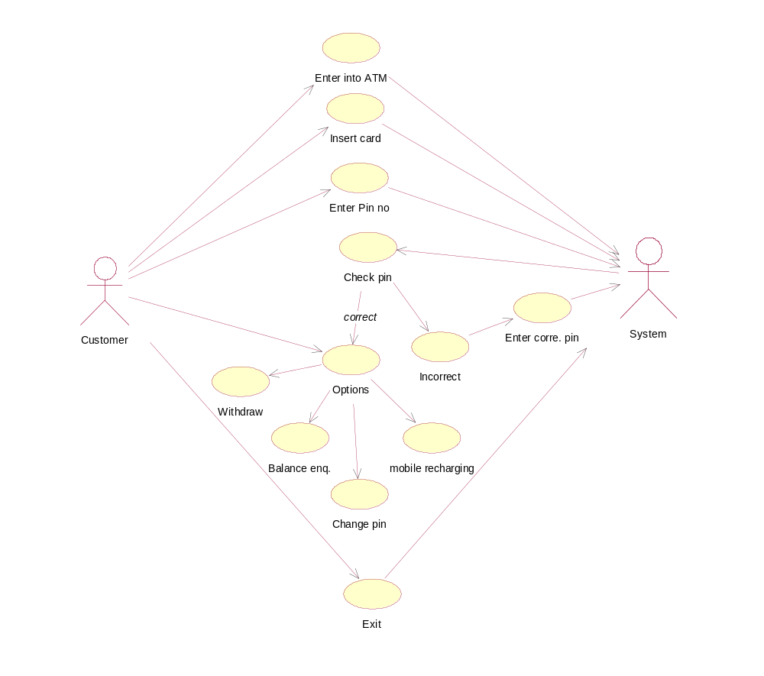

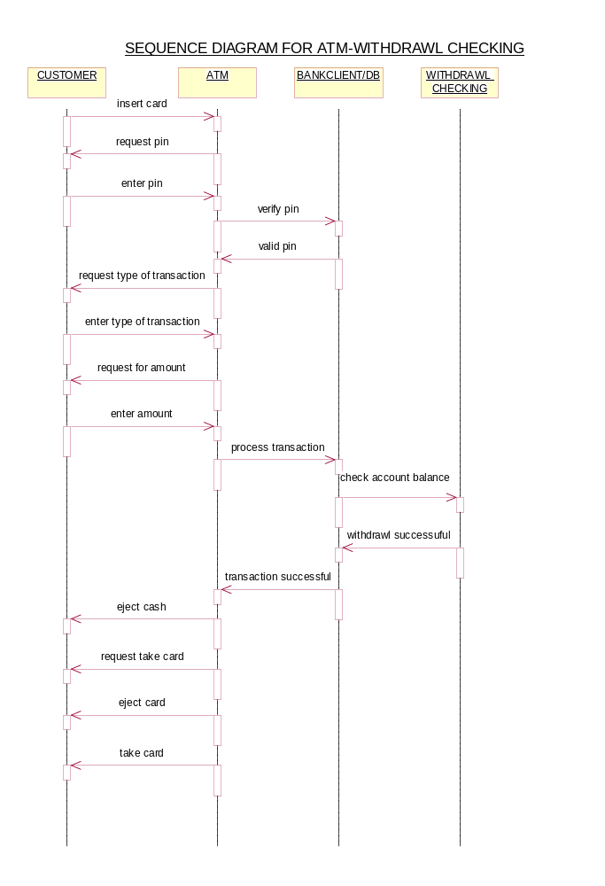

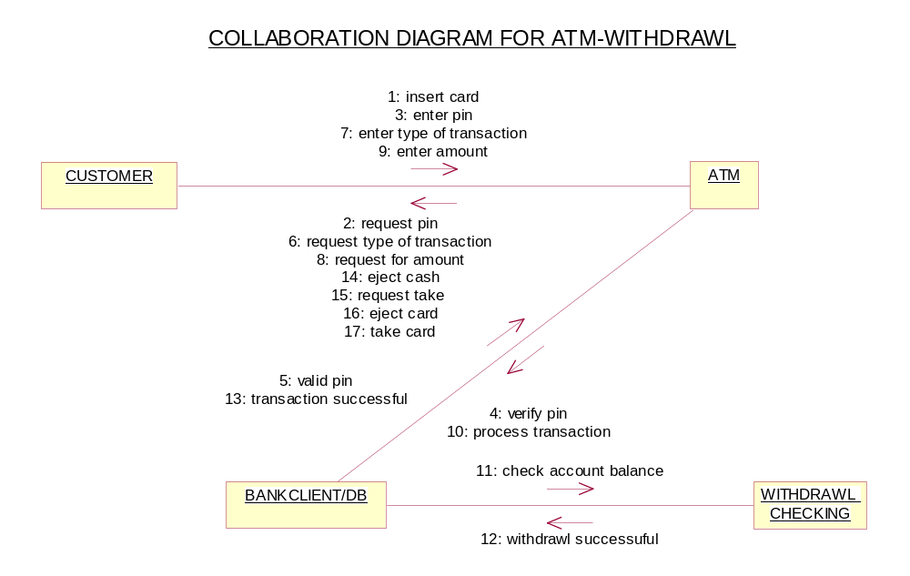

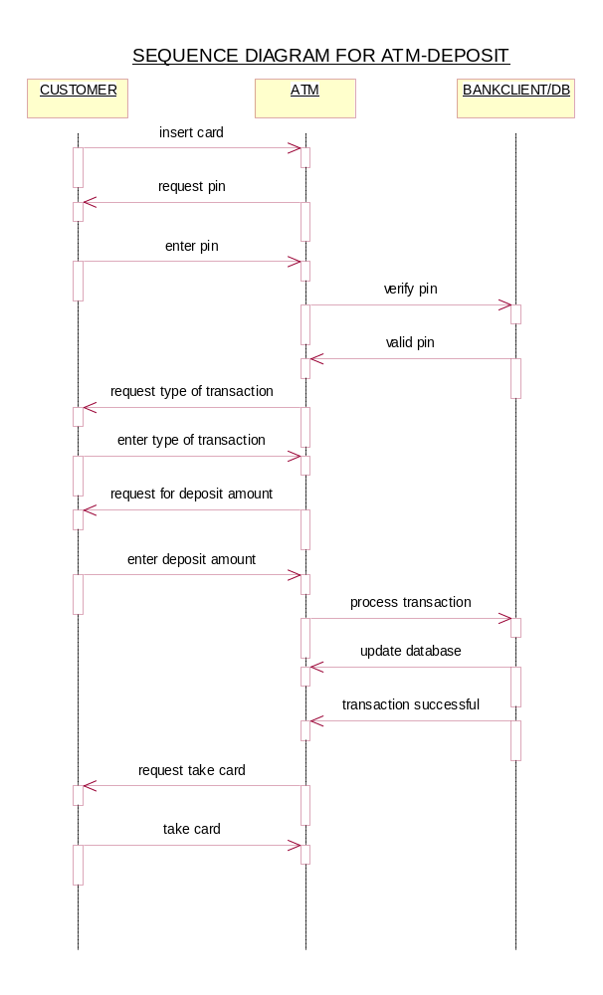

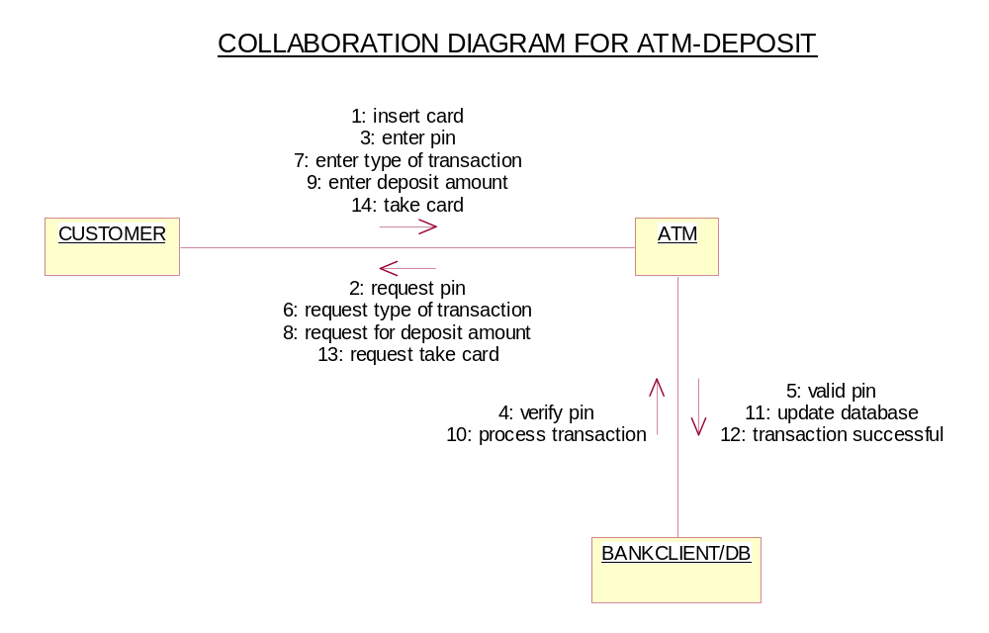

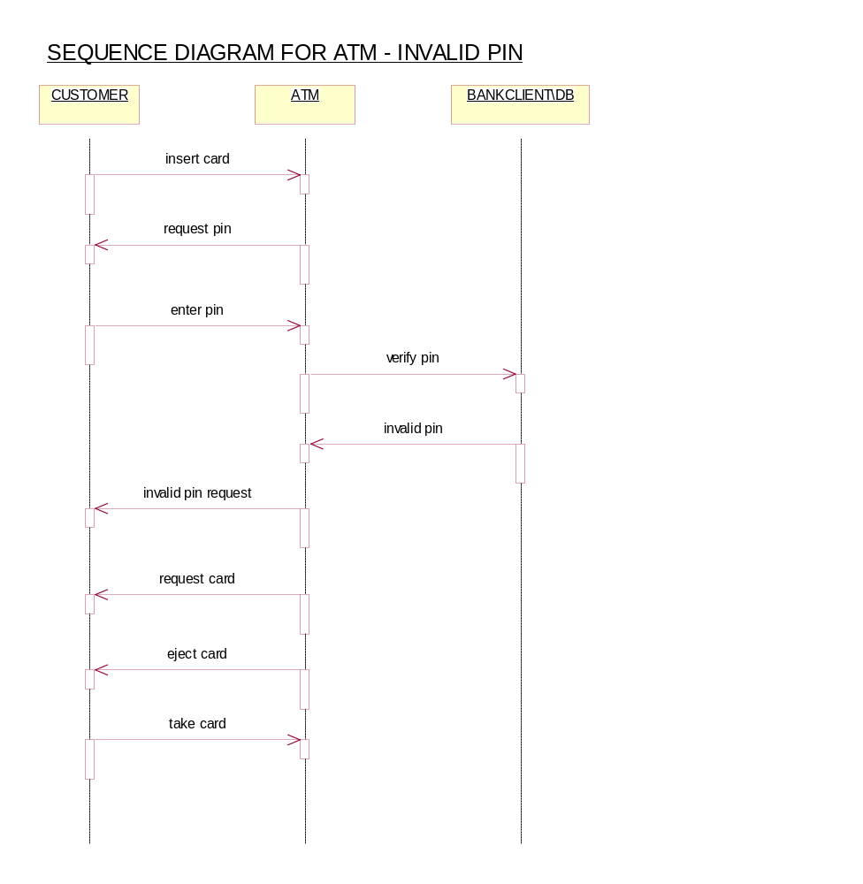

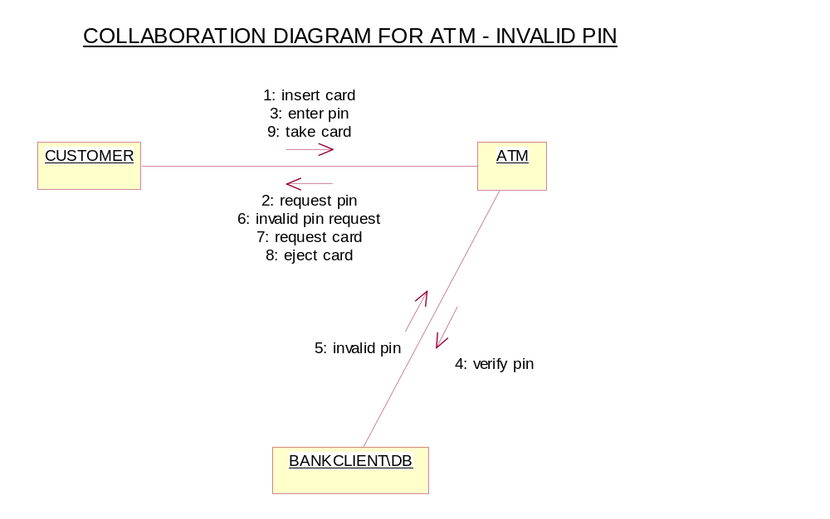

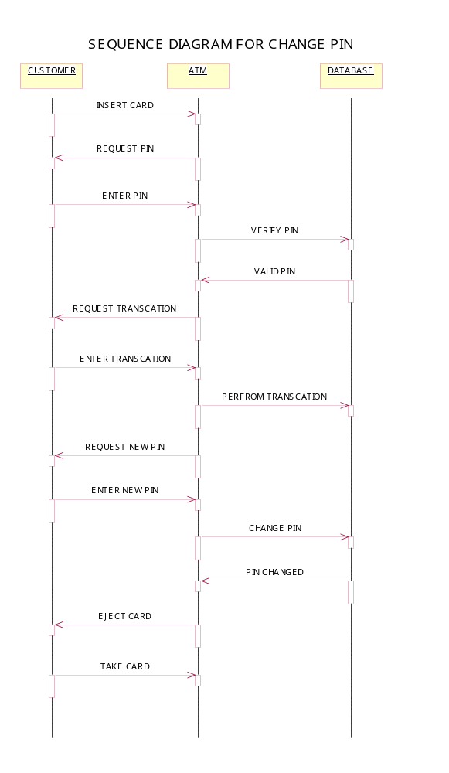

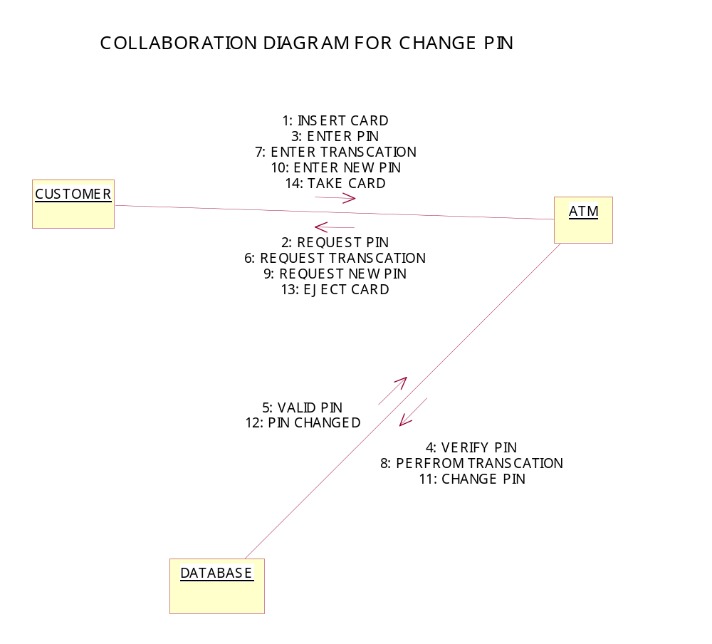

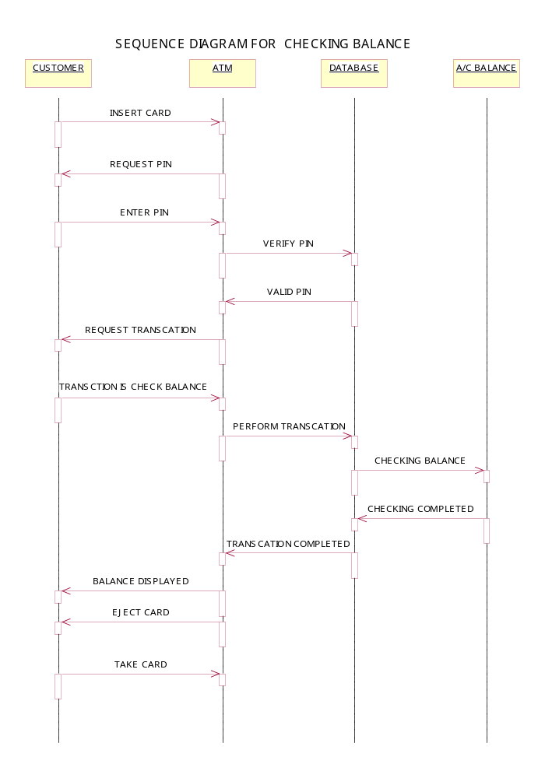

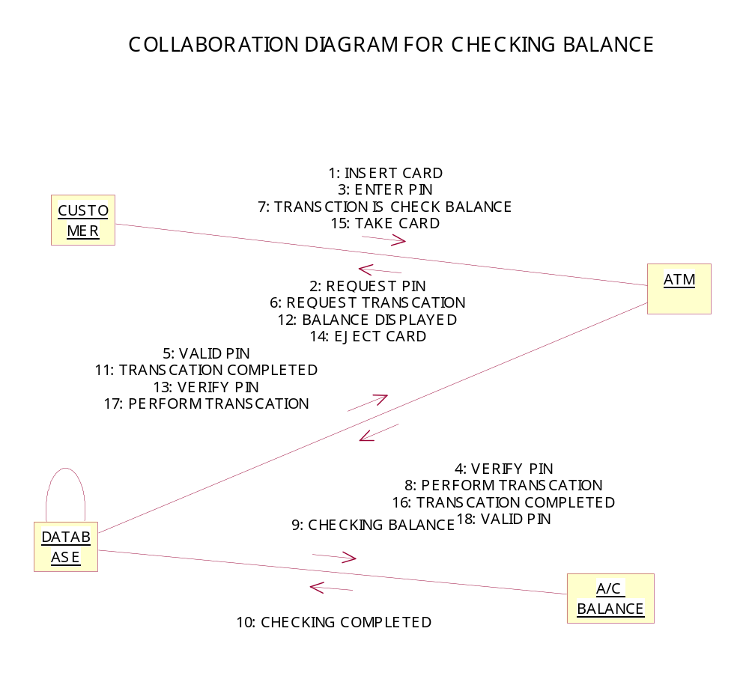

Enter into atm
Insert card
Enter pin no
Check pin
Request type of transaction
Enter the type of transaction
withdrawl
deposit
Not perform
perform
perform
Not perform
Not perform
correct
incorrect

ACTIVITY DIAGRAM FOR ATM APPLICATION

Check a\c balance
Change pin
Mobile recharging
Perform transaction
Take card
No more transactions
More transactions
perform
Not perform
perform
perform
Not perform

CLASS DIAGRAM FOR ATM APPLICATION

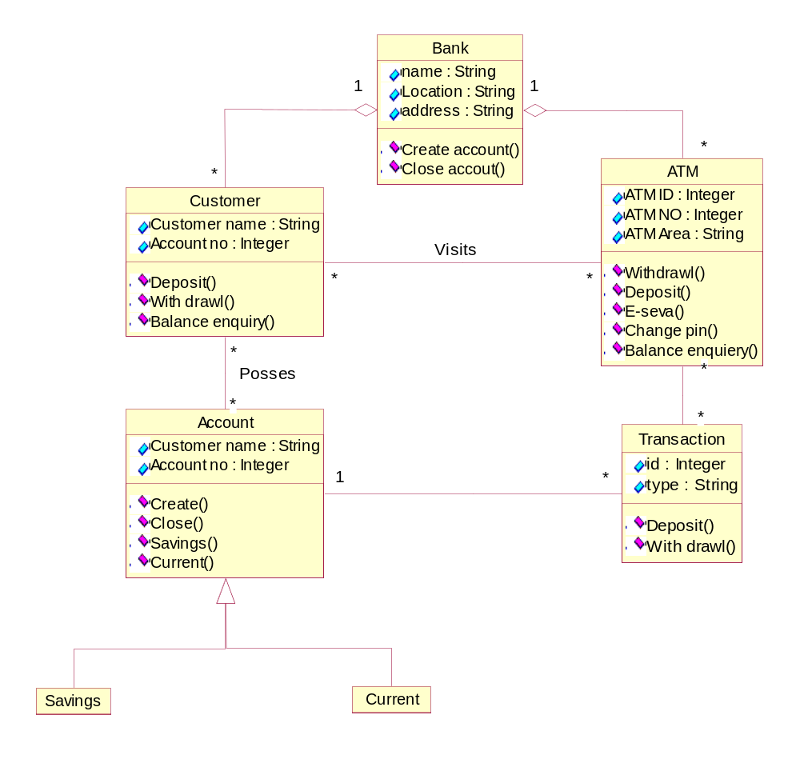

ONLINE BOOKSHOP

Aim:
To create an UML diagram of online bookshop.

Actors:
1.customer
2.system
3.shopkeeper

Usecase:
1.enter website
2.login
3.enter details of book
4.subject name
5.author &edition
6.book cost
7.enter credit card number
8.enter address
9.delivery
10.verify online request
11.details about books
12.details about customer &credit card.

Control flow:

1.customer enters website in the system.
2.Customer login in the system
3.customer enters the details of the book
4.customer specifies the subject name and author and edition of the
book required.
6.customer enters his credit card number in the system.
7.customer enters his address in the system
8.shopkeepers verify online requests and send it to customer.
9. Shopkeeper gives details about books that are not available.
10.system gives details about customer and credit card to the
shopkeeper
11.shopkeeper delivers book to the customer
.

USECASE DIAGRAM FOR ONLINE BOOKSHOP

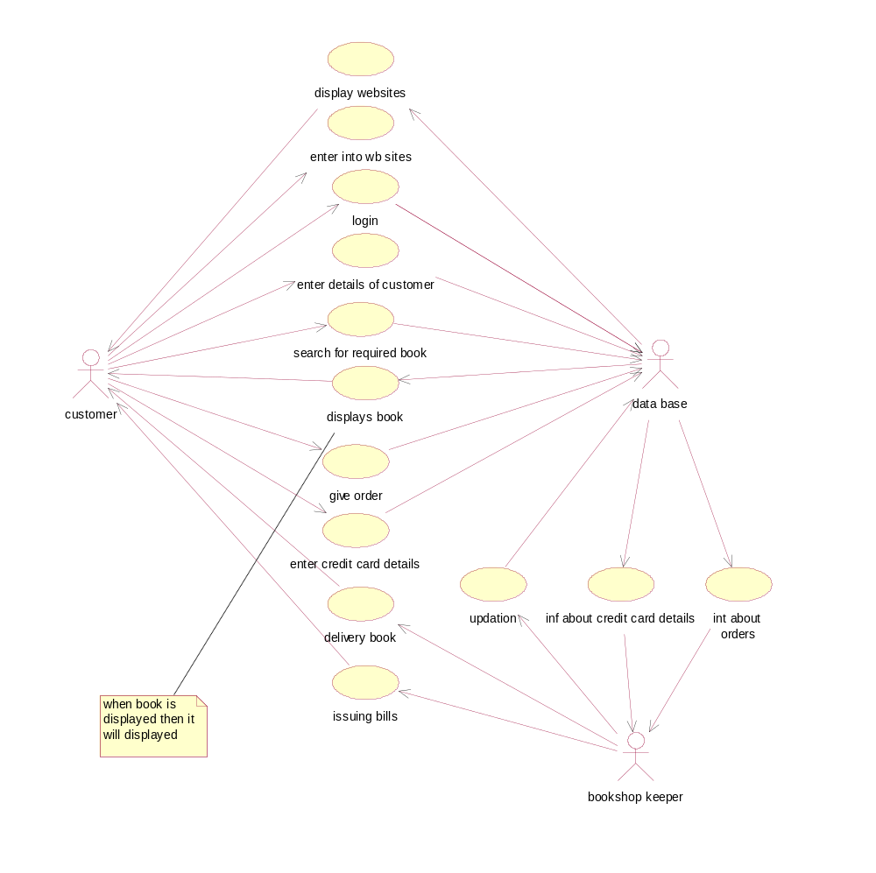

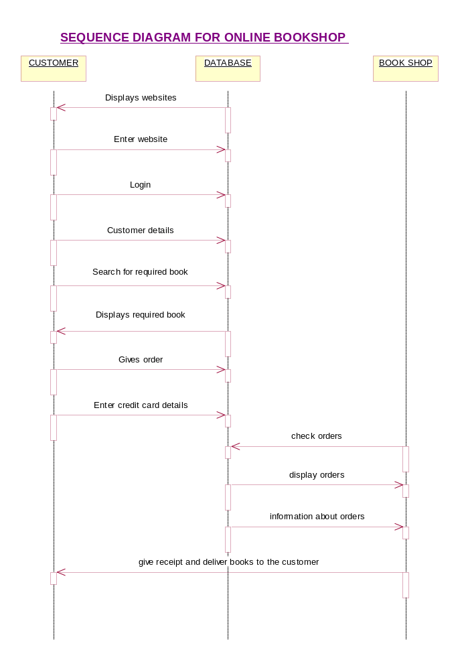

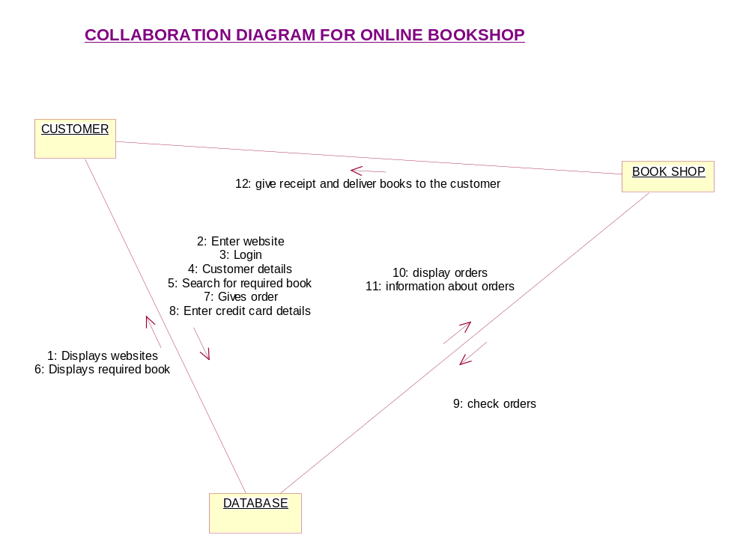

ACTIVITY DIAGRAM FOR ONLINE BOOKSHOP

Show websites

Enter website

Login

Enter name

Enter password

No of books Required
Is magazines?
Yes
Require textbooks
Require magazines
Get ID
No
Enter Credit card details
Deliver books to customer
Deliver Bills
Logout

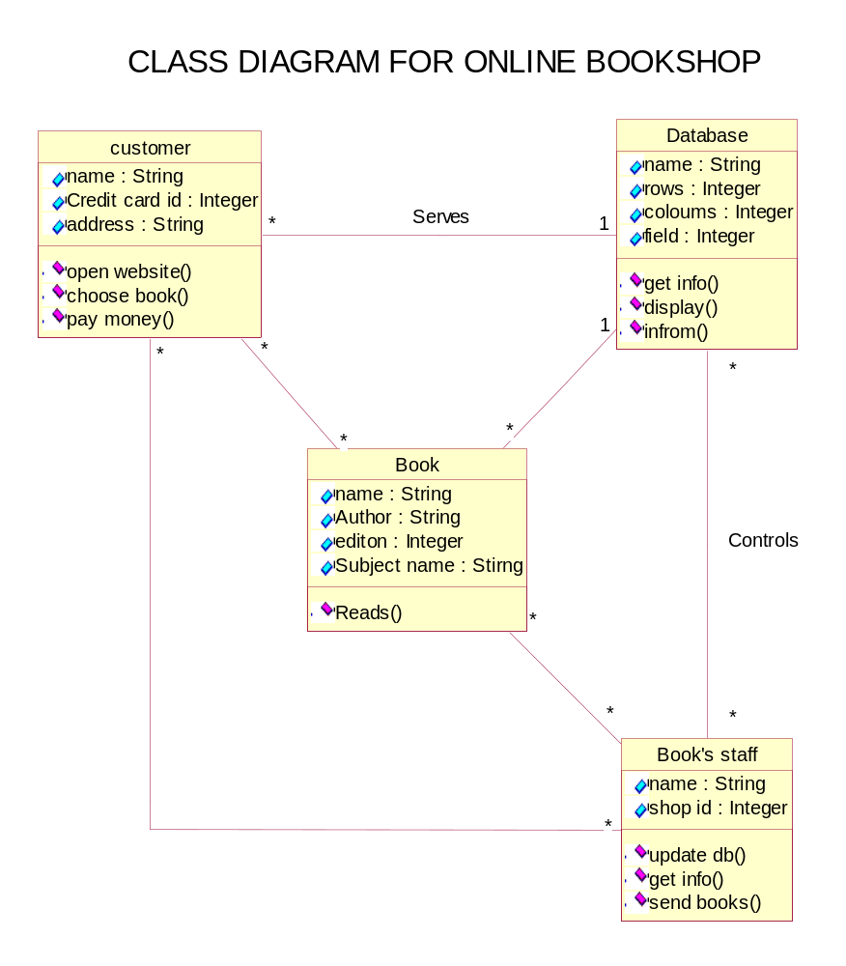

LIBRARY MANAGEMENT

Aim:

To create a UML diagram of library management.

Actors:

1.manager
2.librarion
3.member
4.bookkeeper

Usecase:

1.help
2.request for stock
3.controlling
4.create member account
5.close member account
6.issue membership
7.collecting books
8.renual book
9.return book
10.fine details
11.request for books
12.control
13.requesting books
14.help.

Control flow:

1. manager of the library help the librarian in all possible ways.
2.librarion requests the manager for the new stock.
3. manager looks after many control activities of the library.
4. librarian allows a new member to create an account.
5. librarian allows the member to close his account.
6. Librarian issues the membership for the member.
7.member collects the books he needed from librarian.
8.member renewal the books from the librarian.
9.member returns his books to the librarian.
10.member pays the fine to the librarian in case of any damage
to book or late issuing.
11.librarion maintains the books with the help of bookkeeper.

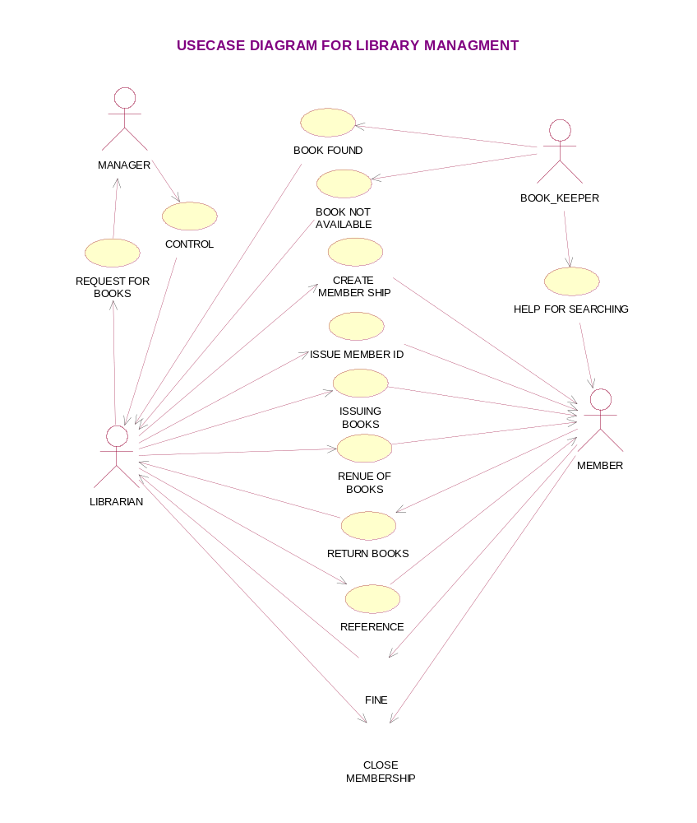

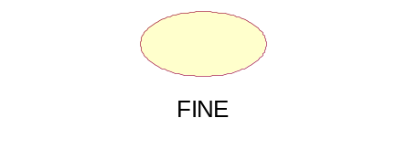

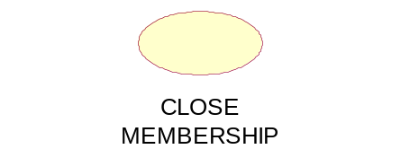

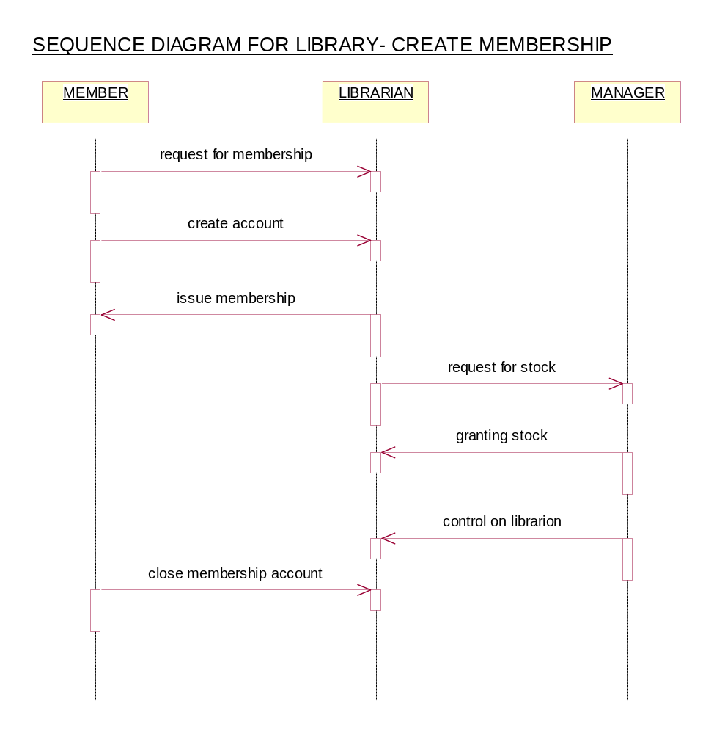

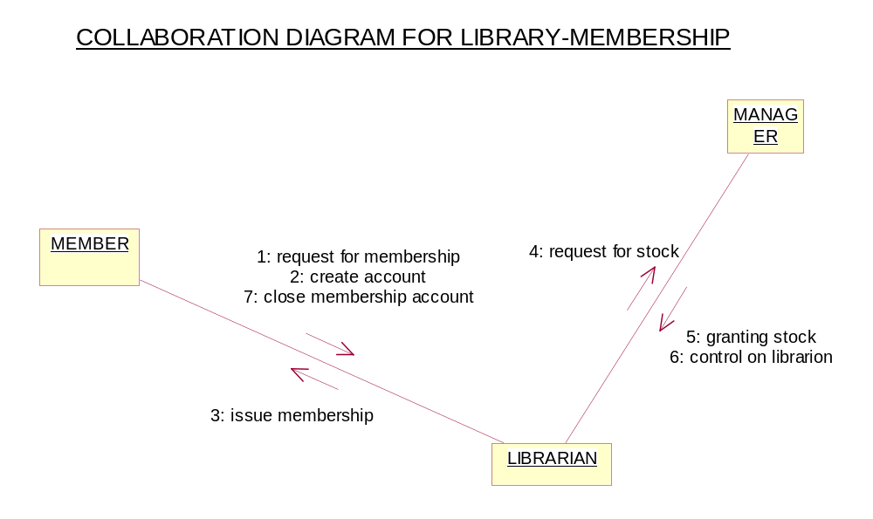

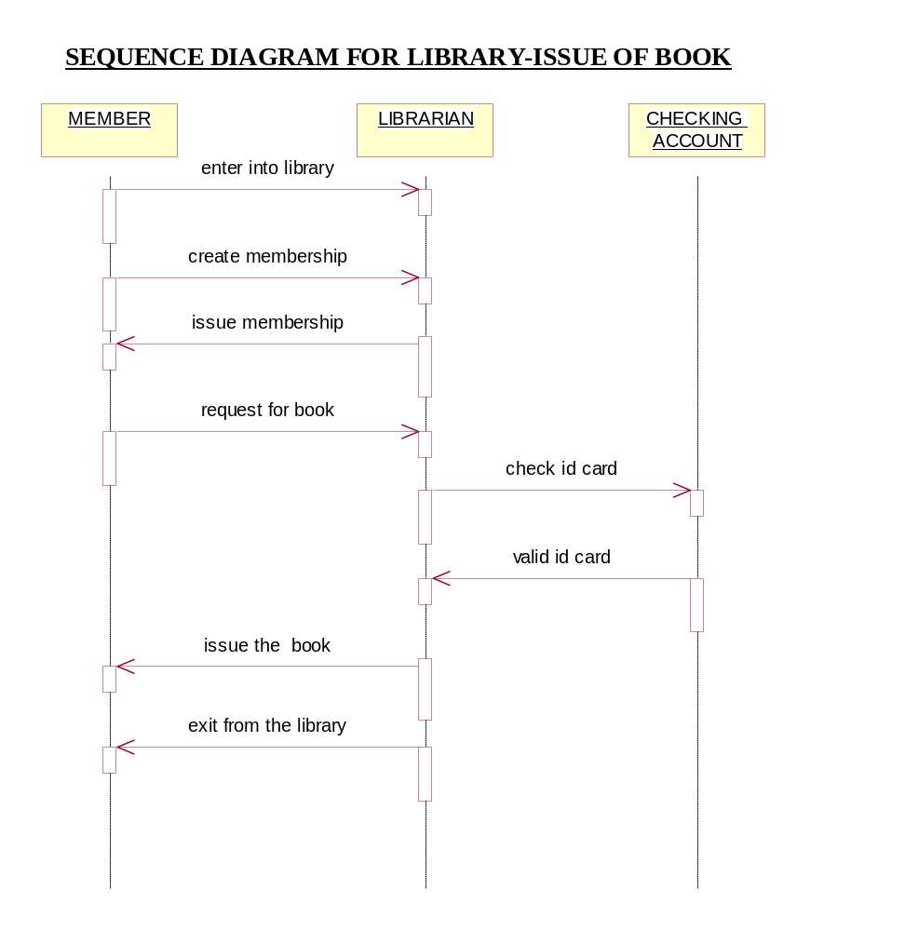

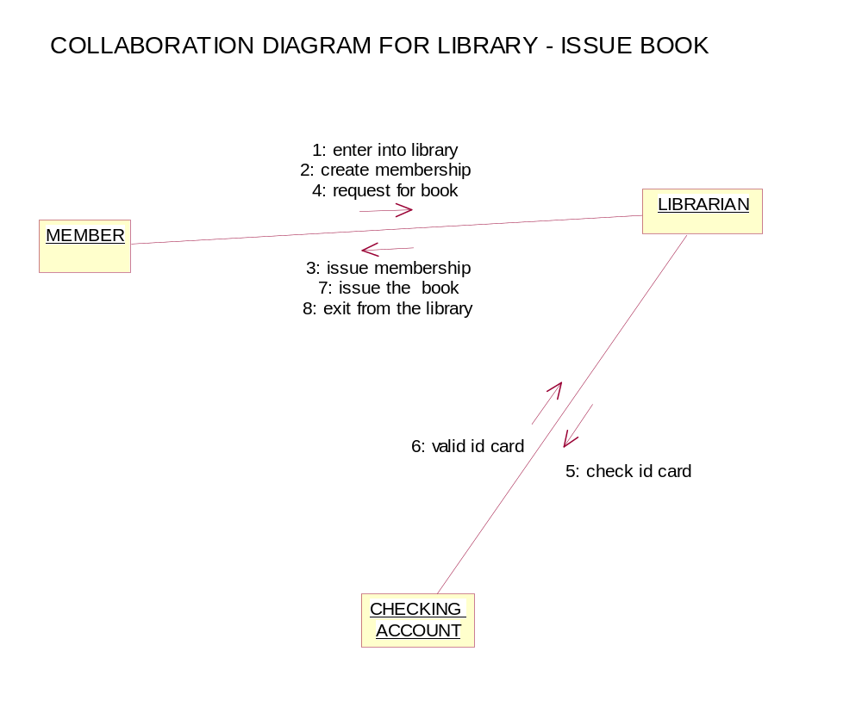

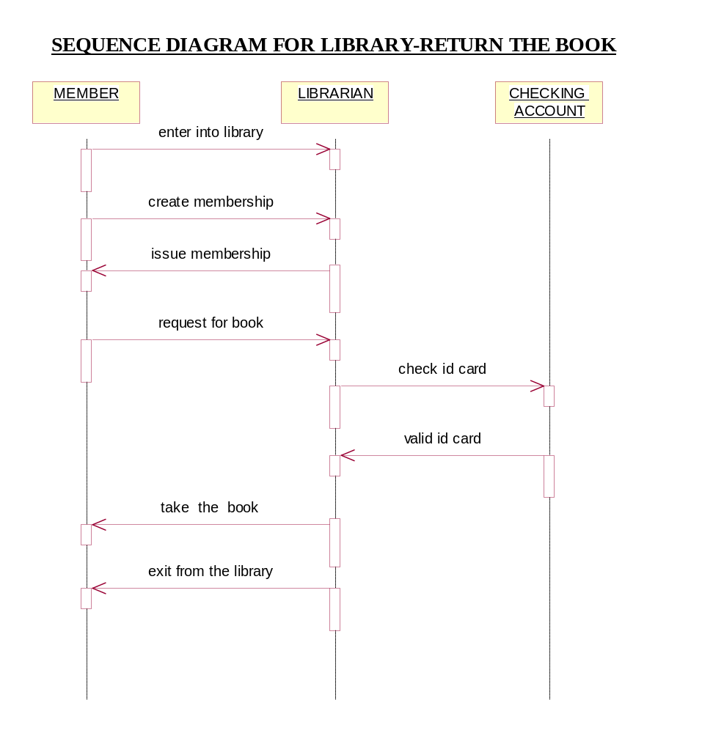

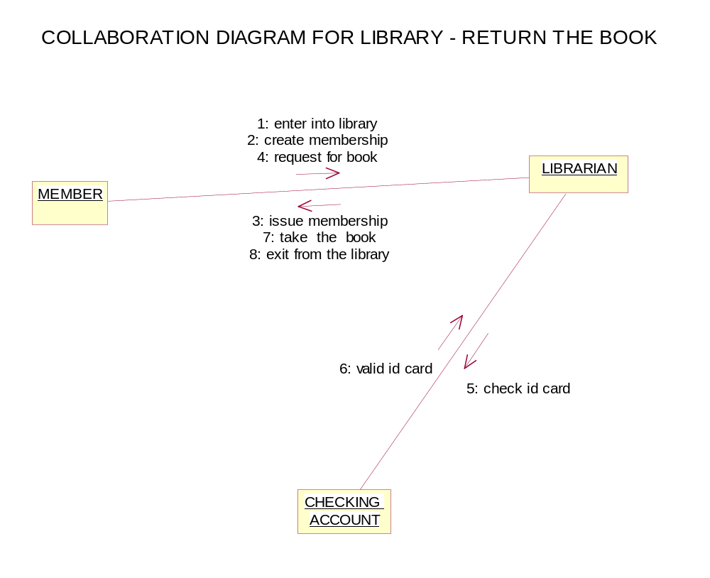

ACTIVITY DIAGRAM FOR LIBRARY MANAGEMENT– MEMBER

Creates member ship account

Close member ship account

Request books

Collects books

Return books

ACTIVITY DIAGRAM FOR LIBRARY MANAGEMENT – LIBRARIAN

Issue member ship
Renews the book
Gives information about fine details
Has control on book-keeper

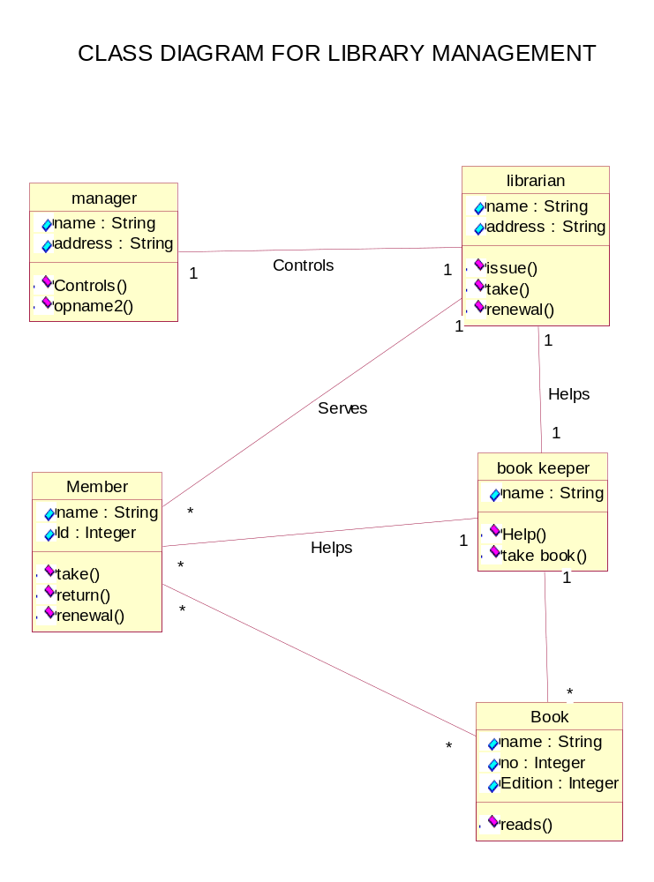

AIRPORT SIMULATION

Aim:

To create a UML diagram of airport simulation.

Actors:

1.aircraft
2.airport

Use case:

1.enters into
2.airport
3.check
4.gates
5.runways
6.landing
7.takeoff
8.station
9.enquiry
10.waiting rooms
11.shops
12.verification counter

Control flow:

1. Aircraft enters into airport
2. It includes check for recant gate
3. From gates go to runways by using taxis
4. Runway uses either landing or takeoff
5. Airport also includes station
6. Station consists of waiting rooms and shops
7. Enquiry and verification counter is done in the station.

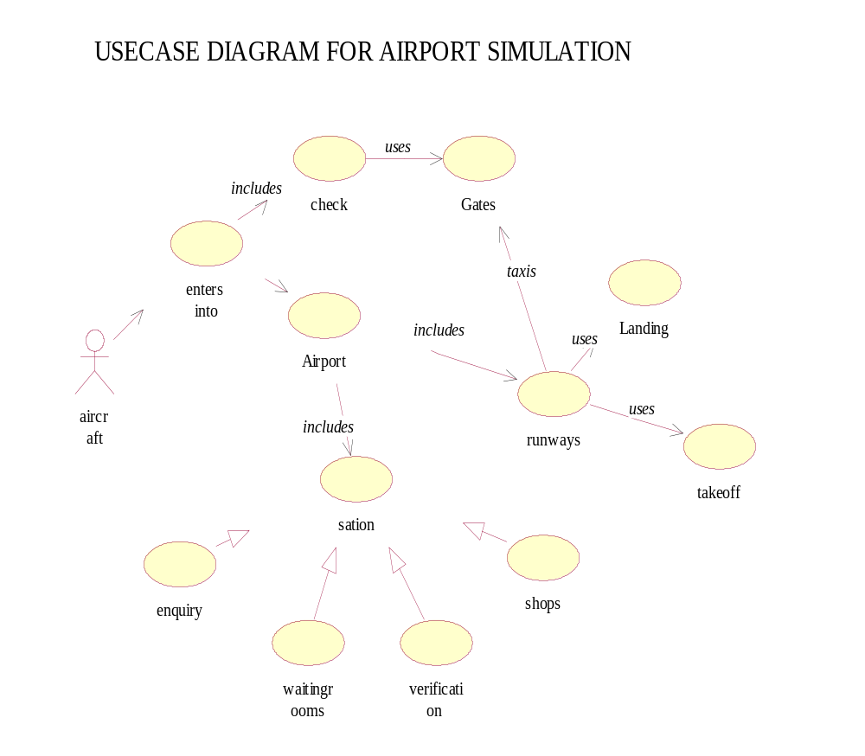

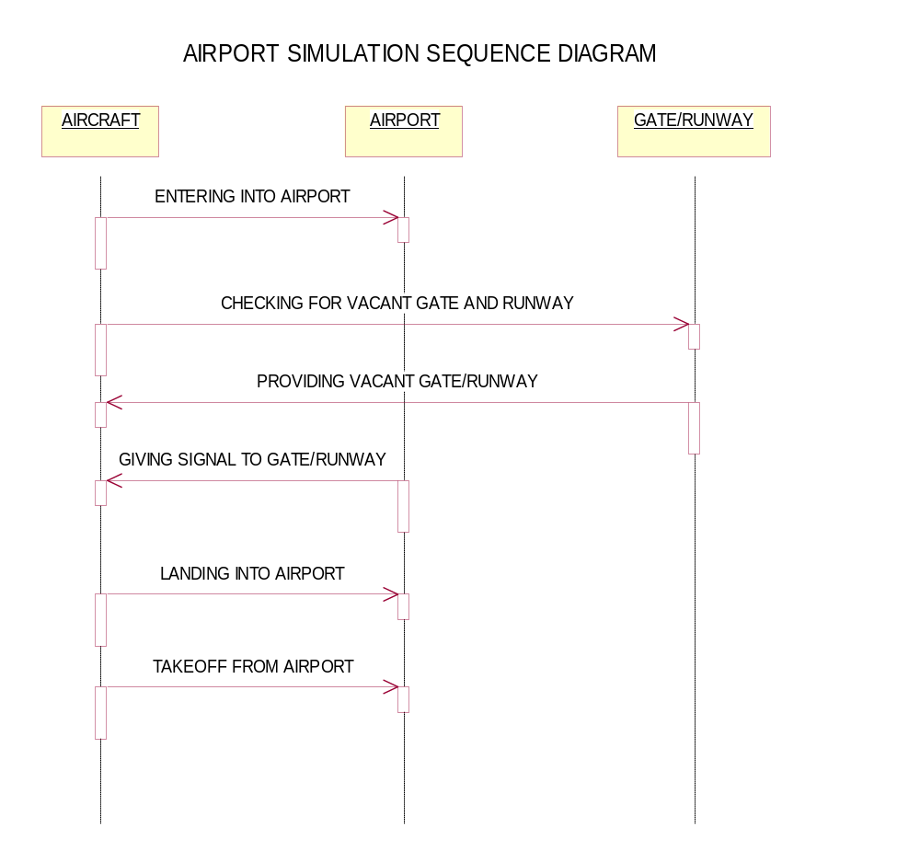

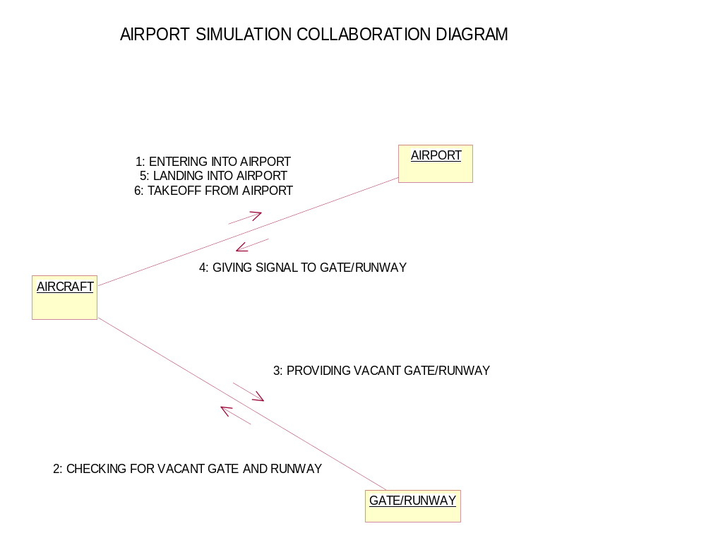

ACTIVITY DIAGRAM FOR MULTI THREADED AIRPORT SIMULATION
ENTER INTO AIRPORT
CHECK GATES
ENTER INTO RUNWAYS
TAKE OFF
LANDING
IF LANDING
IF TAKEOFF

CLASS DIAGRAM FOR AIR PORT STIMULATION

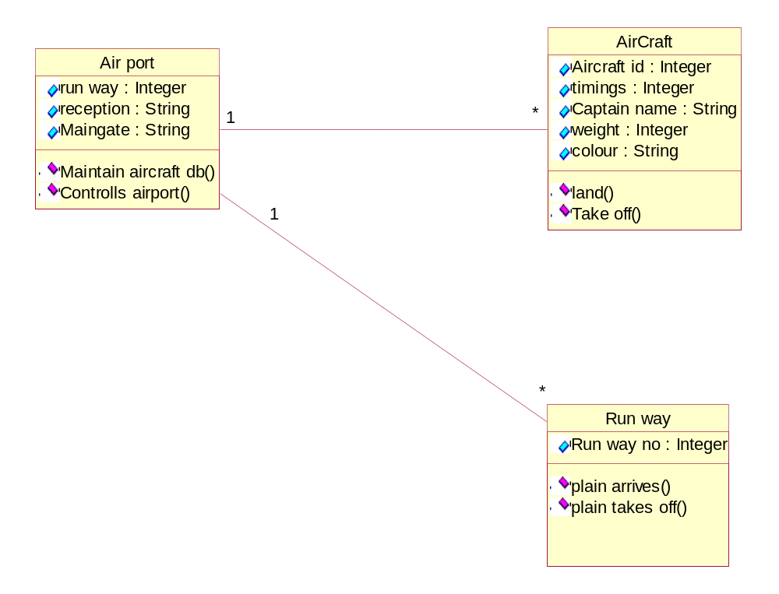

BANKING SYSTEM

Aim:
To create a uml diagram of banking system.

Actors:
1.manager
2.database
3.customer
4.cashier
5.accountant

Usecase:

1.create account
2.closing account
3.passbook confirmation
4.loans
a) General loans
b) Personal loans
i) Health loans
ii) House loans
5.checking account
6.details about bank
7.balance enquiry
8.dd
9.deposit
10.withdraw
11.upations

control flow:

1.customer contacts manager for creating new account
2.manager maintains database about the customer
3.customer contacts the manager for closing his account
4.manager gives the confirmation about the passbook of the customer
5.customer takes loans from the bank by the help of manager.
6.manager gives general loans and personal loans. Personal loans
includes health loans and house loans
7.customer takes the help of accountant for checking his account.
8.customer knows the details of the bank from accountant.
9.customer contacts cashier for DD deposit and withdraw
10.cashier makes updating for the customer database if he performs
any transactions such as taking DD withdrawing money or
depositing some money.

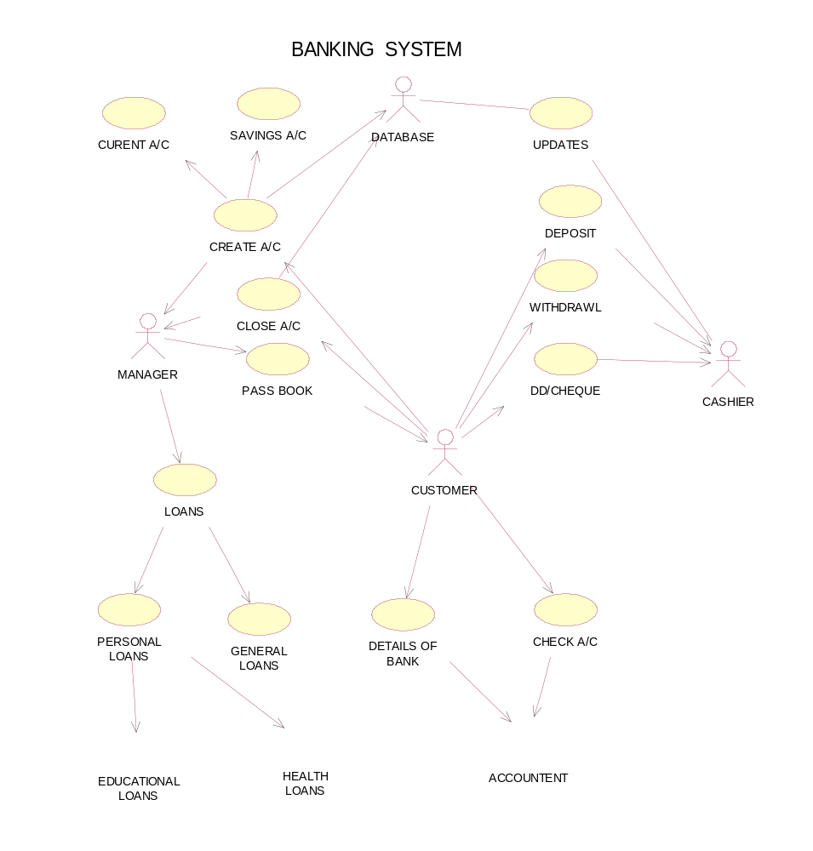

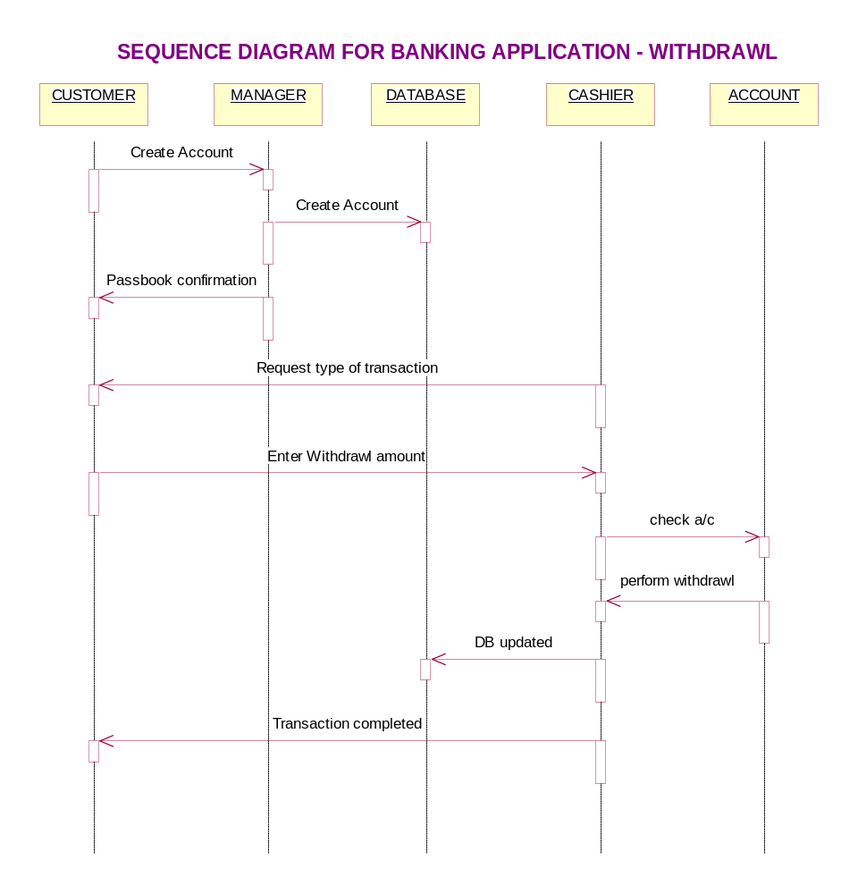

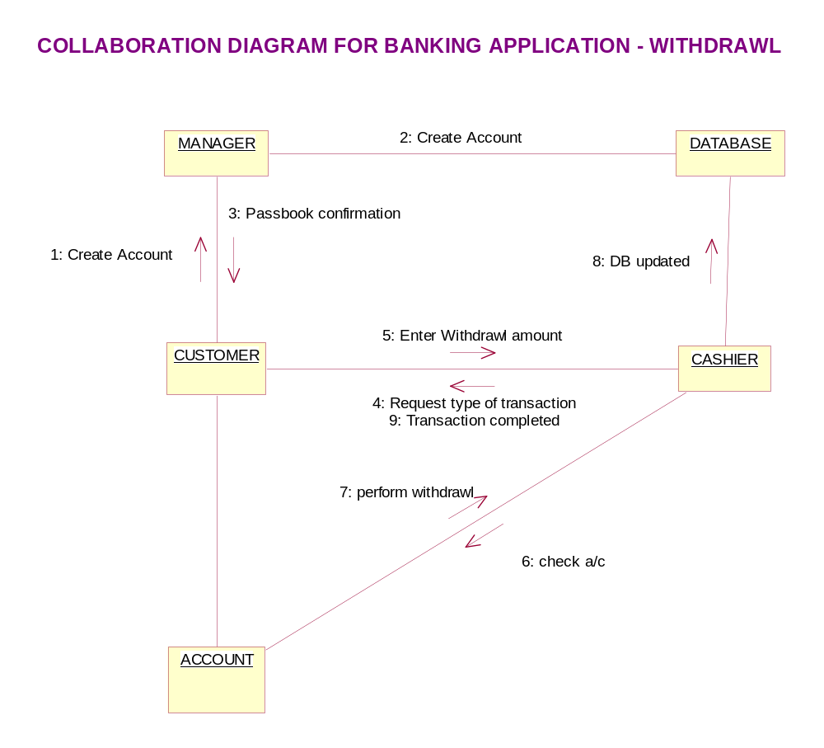

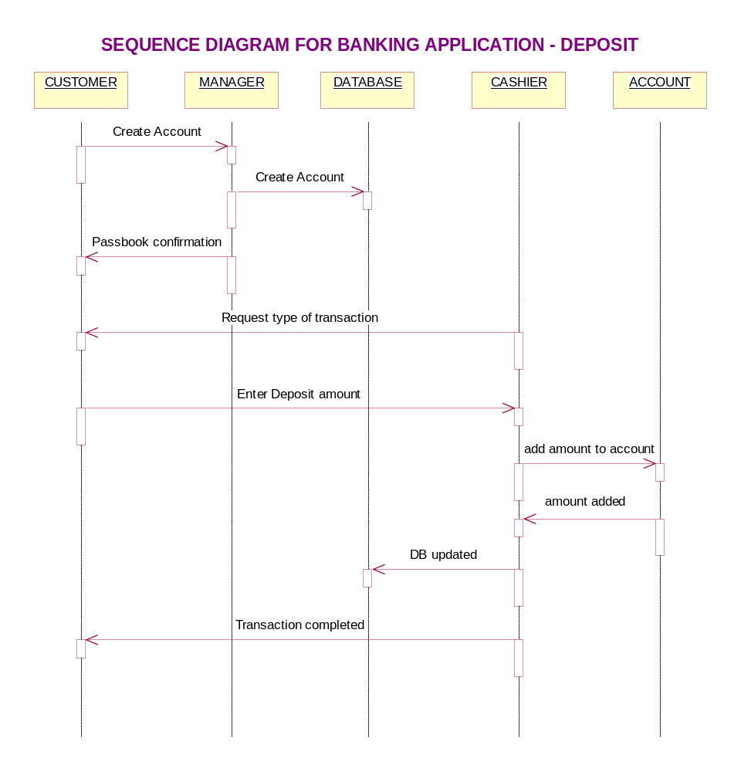

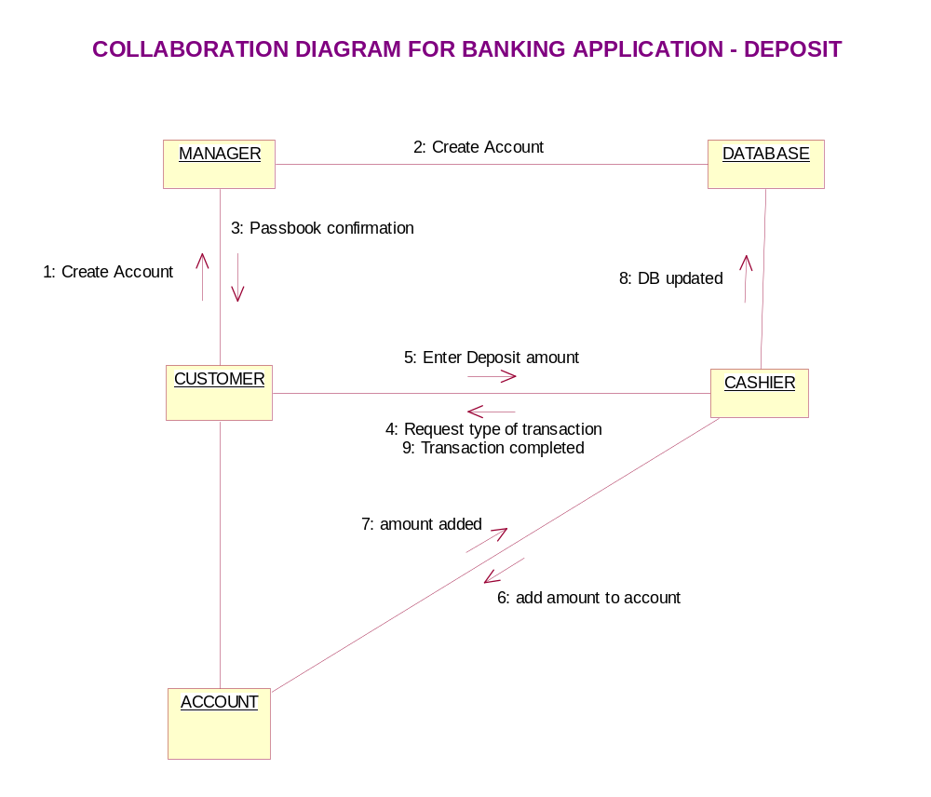

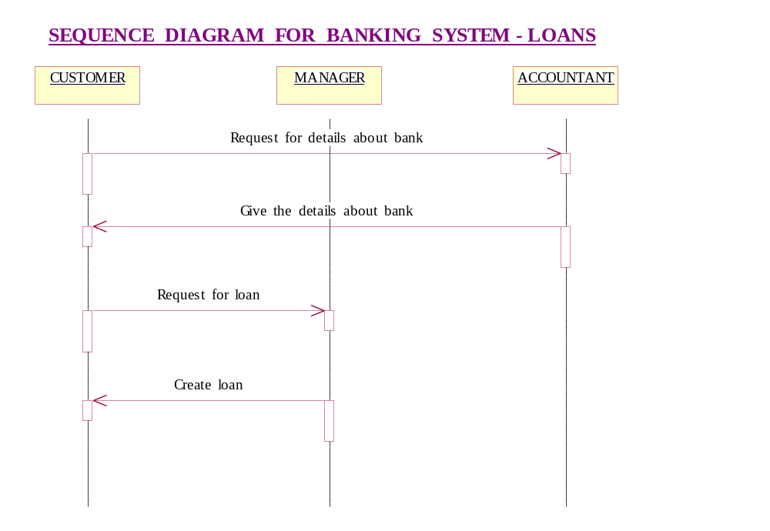

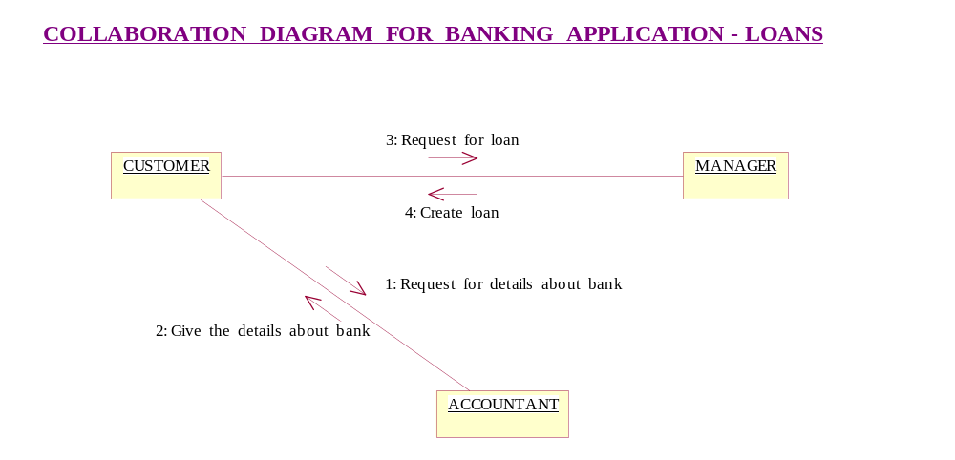

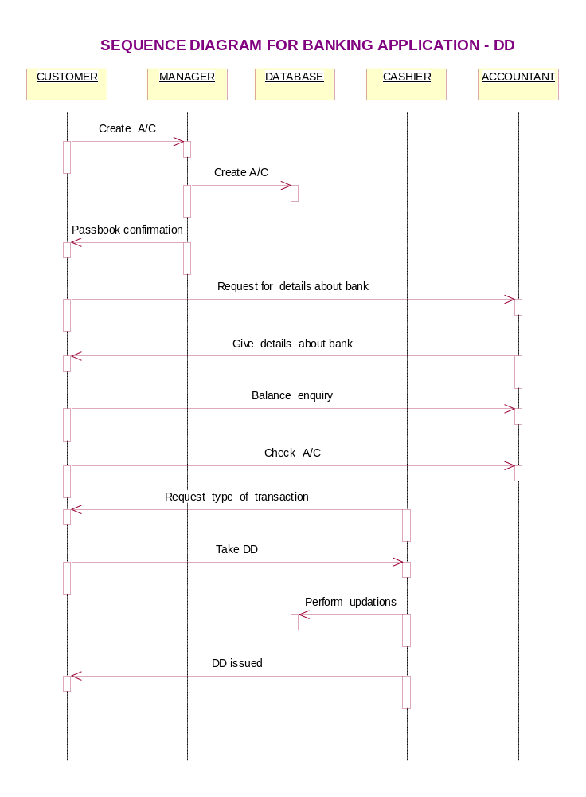

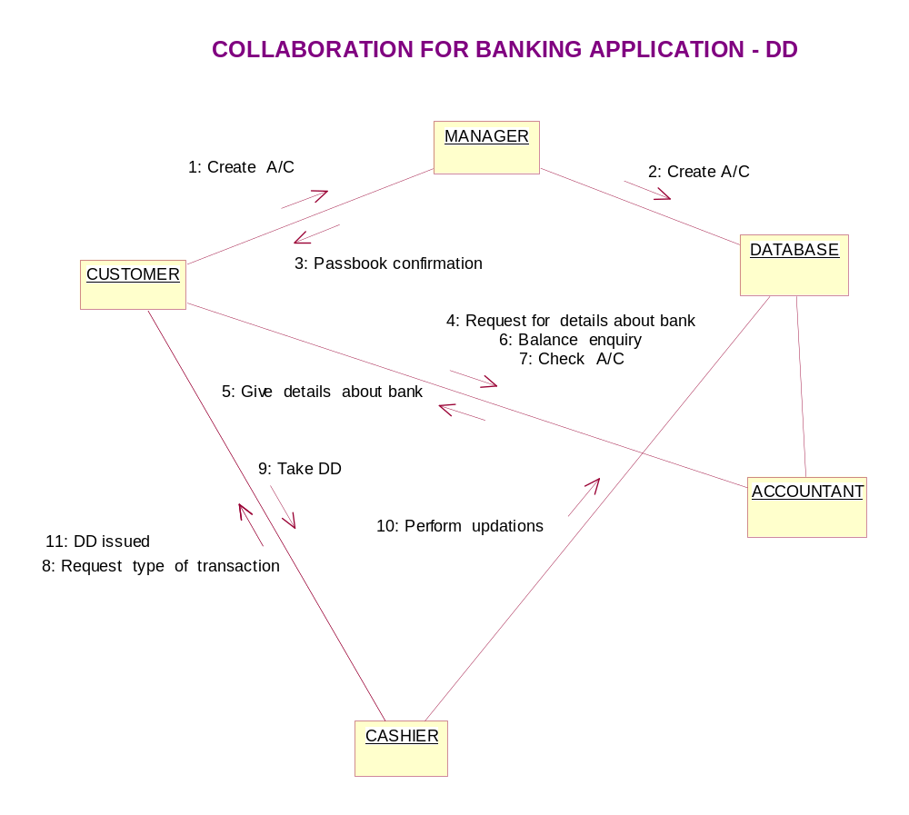

ACTIVITY DIAGRAM FOR BANKING SYSTEM – CUSTOMER

Create account
Close account
Make passbook confirmation

Create loans

Personal loans
General loans

Check account
Make balance enquiry

Details about banks

Take DD

deposit

With drawl

ACTIVITY DIAGRAM FOR BANKING SYSTEM – MANAGER

Creates account in database

Closes account in database

Gives passbook confirmation

Gives loans

ACTIVITY DIAGRAM FOR BANKING SYSTEM – ACCOUNTANT

Checks account
Gives details about banks
Gives information about balance amount

CLASS DIAGRAM FOR BANKING APPLICATION

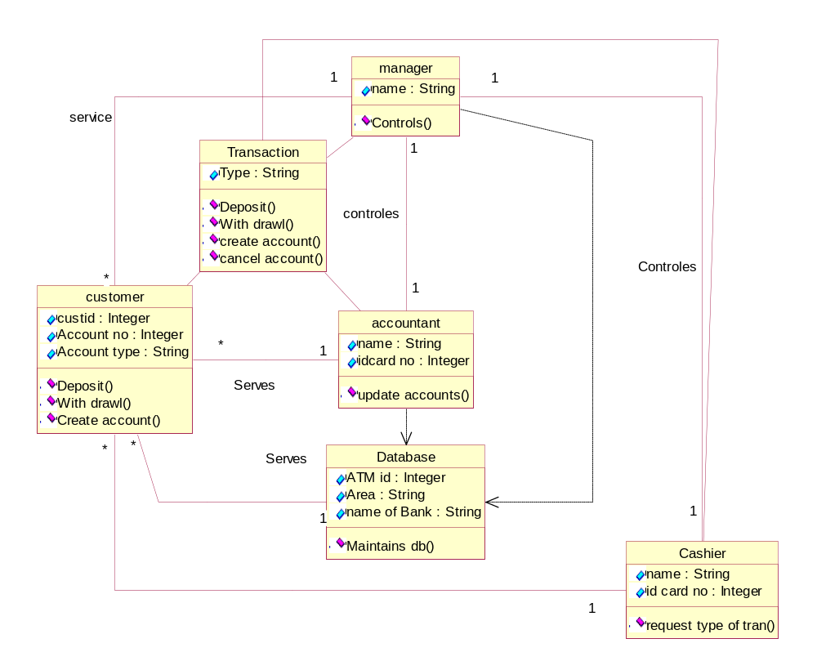

ONLINE RAILWAY RESERVATION

Aim:

To create a UML diagram of online reservation.

Actors:

1.customer.
2.system.

Usecase:

1.enter website.
2.enter source, destination
3.enter date
4.list of trains
5.choose train
6.available seats
7enter no. of seats
8.enter credit card details
9.ticket confirmation
10.exit.

Control flow:

1. Customer enters website in the system
2. Customer enters source from where he starts to destination where
he reaches into system
3. Customer enter the data in the system
4. Customer checks the list of trains in the system
5. Customer chooses the train required in the system
6. Customer verifies the available seats in the system.
7. Customer enters number of seats required in the system.
8. Customer enters his credit card details in the system.
9. Customer verifies whether ticket conformed or not.
10. Customer exit from the system.

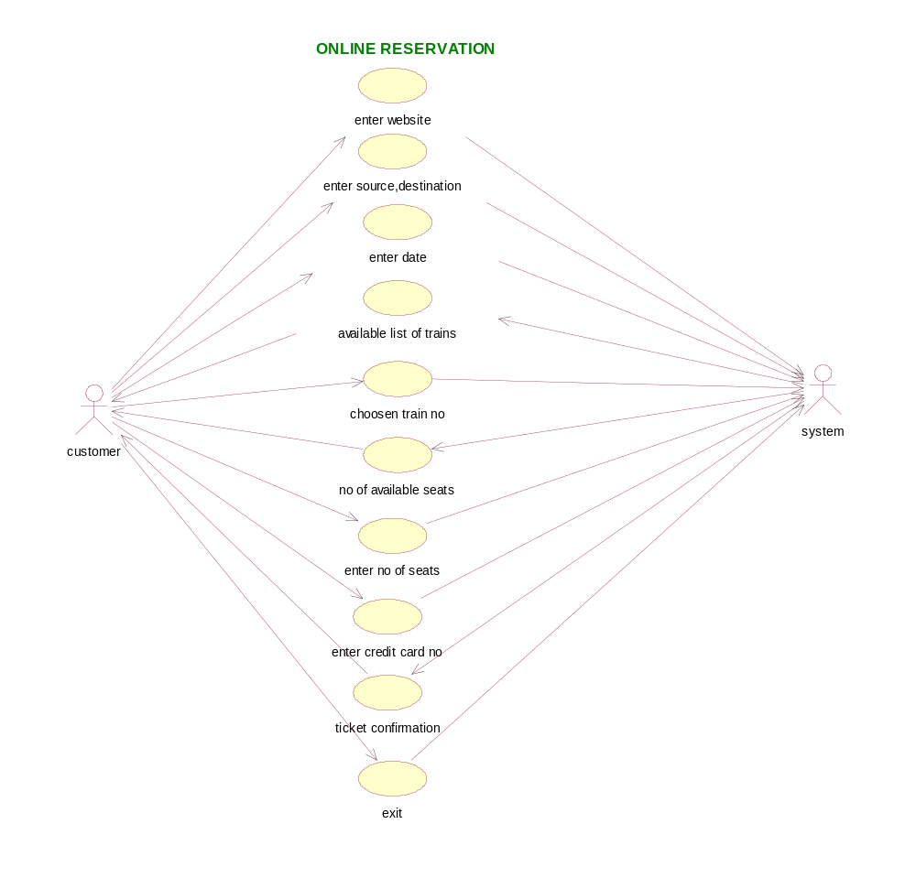

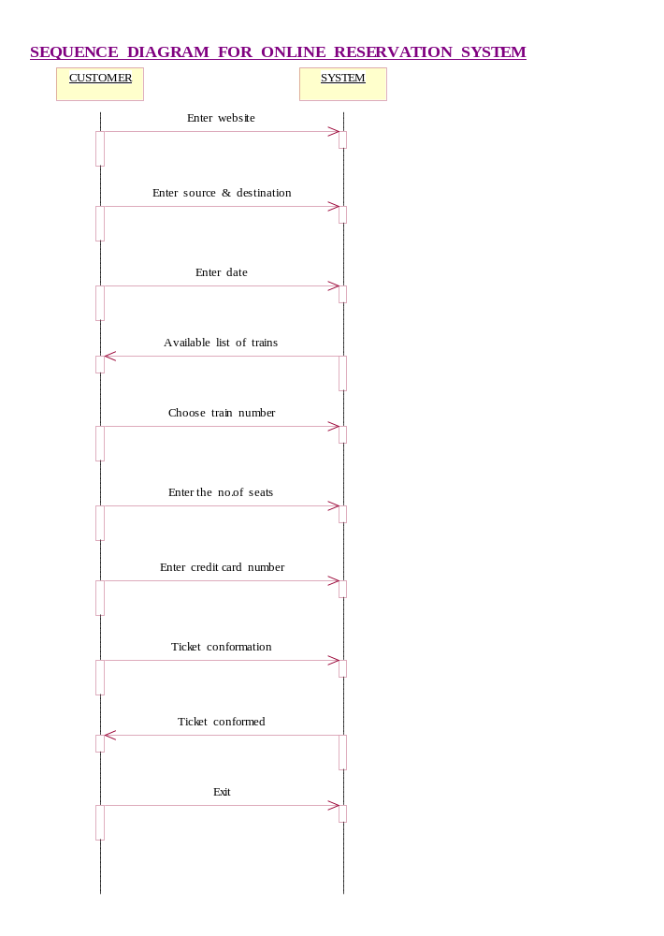

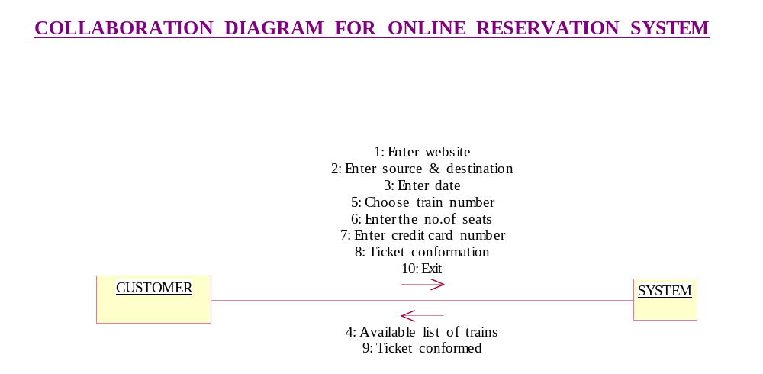

valid
Ticket Confirmation
Enter web site
Enter Source
Enter Destination
Enter Date
valid
Available List
Choose Train
Number Of Available Seats
Enter Number Of Seats
Enter CreditCard Number
yes
yes
no
no
ACTIVITY DIAGRAM FOR ON-LINE RAILWAY RESERVATION
no
no

ONLINE RAILWAY RESERVATION FOR CLASS DIAGRAM

